Spark Streaming: (<https://github.com/subhamkharwal/> )

* 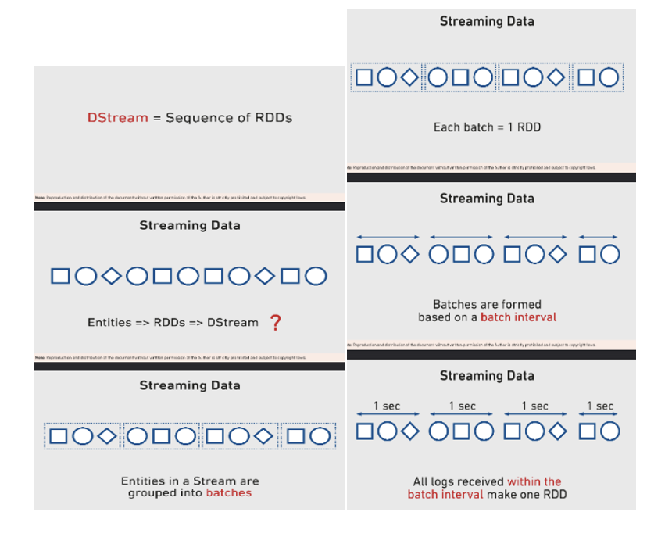

Difference between batch vs streaming:

* 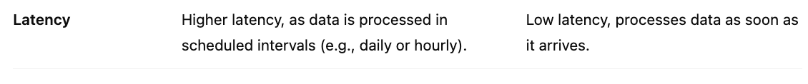
* 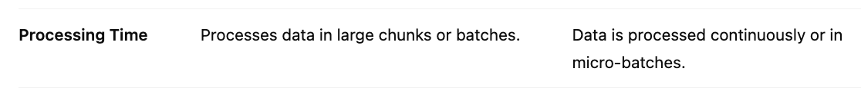
* 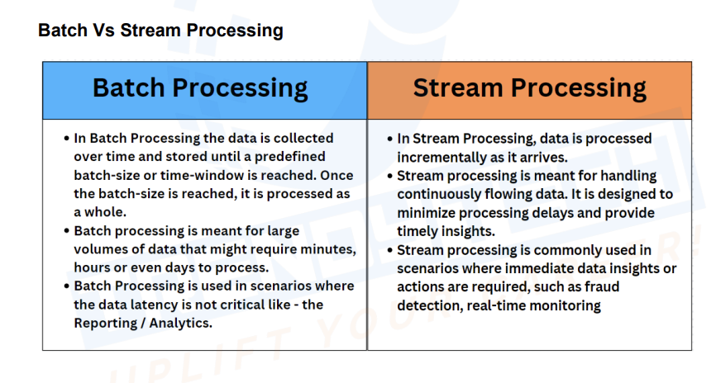

How spark streaming works:

Once we get input data in spark streaming data is split into micro batches, so that spark can consider these as batches and apply same transformation which it does for batch processing

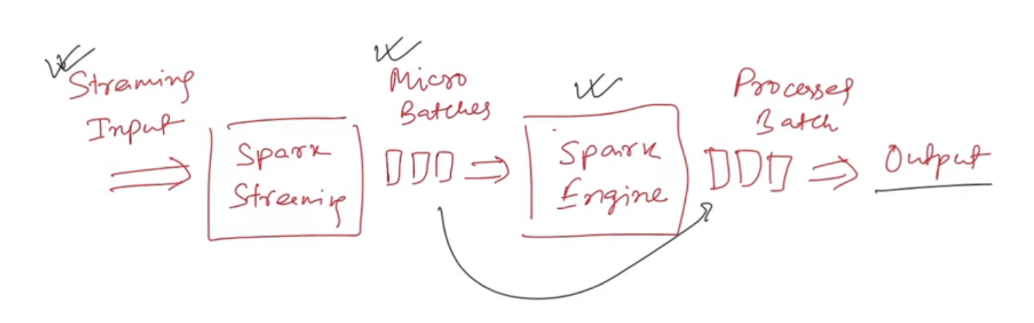

Streaming data is continuously broken down into multiple batches, each batch is continuously processed by spark engine, it uses same dataframe code which is used for spark batch processing

* 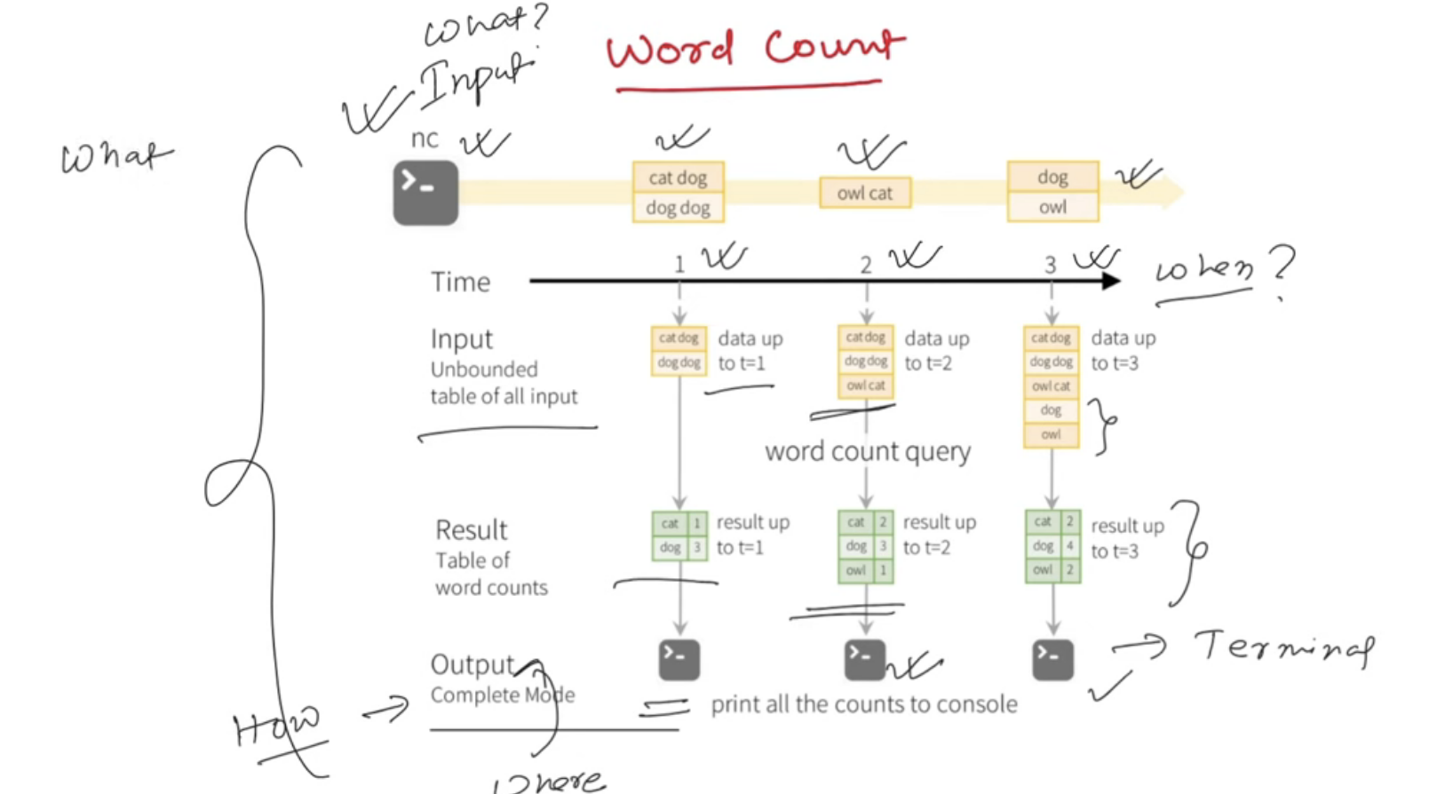

Input Sources:

* 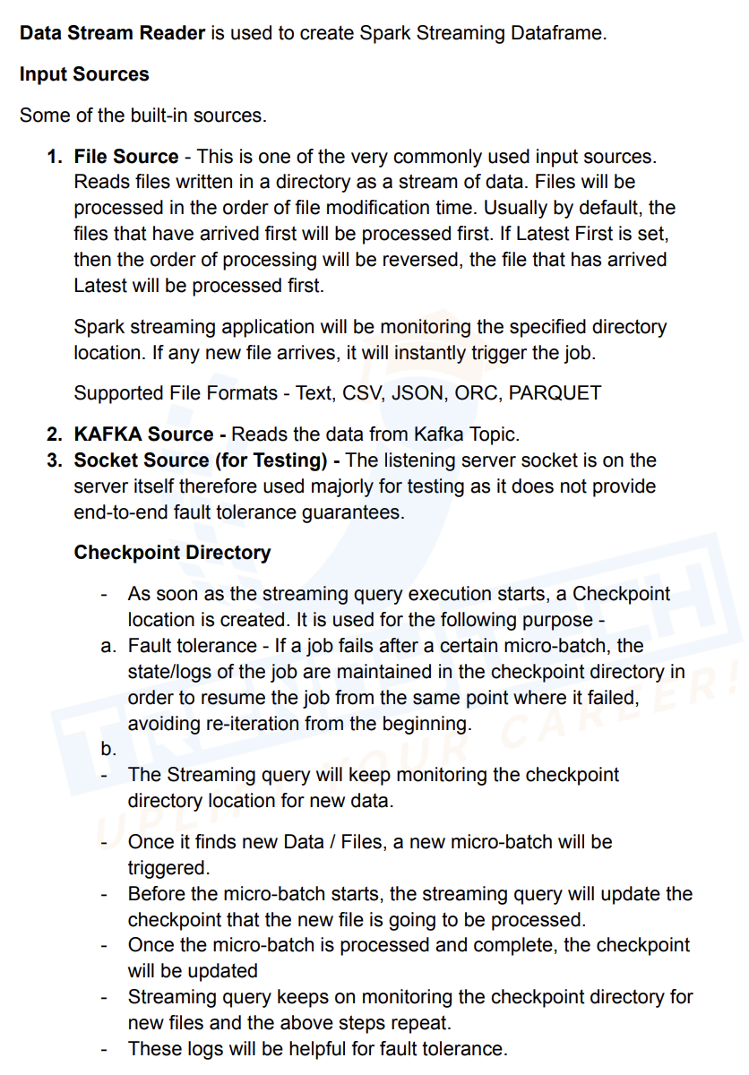

Word Count:

import findspark  
  
findspark.init()  
  
from pyspark.sql import SparkSession  
  
spark = SparkSession.builder.appName("stream").getOrCreate()  
  
df_raw = spark.readStream.format("socket").options(**{"host":"0.0.0.0"**,** "port":**9999**}).load()  
  
from pyspark.sql.functions import *  
  
df_new = df_raw.withColumn("words"**,**explode(split(df_raw.value**,**" "))).groupBy(col('words')).count()  
  
df_new.writeStream.format("console").outputMode("complete").start().awaitTermination()

Output Modes:

* 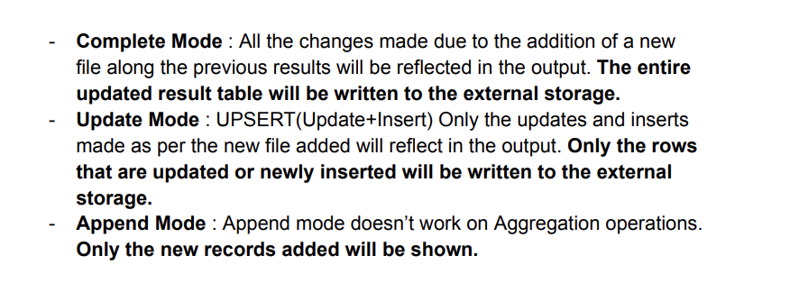

Append mode usually doesn't work for streaming aggregation but it works for water mark as keep storing the state of that interval and once interval expires will show the results

Complete:

* 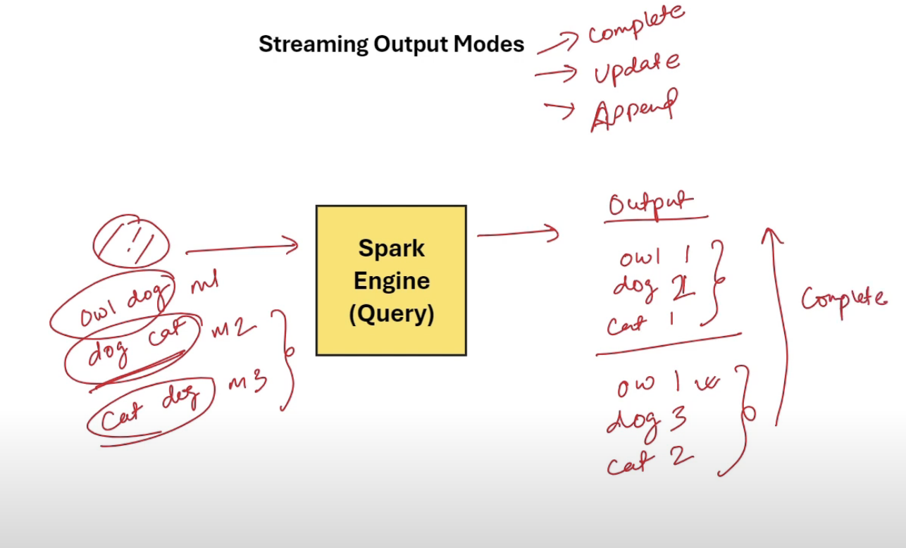

Update:

In Update mode spark will process only the updated and new data

* 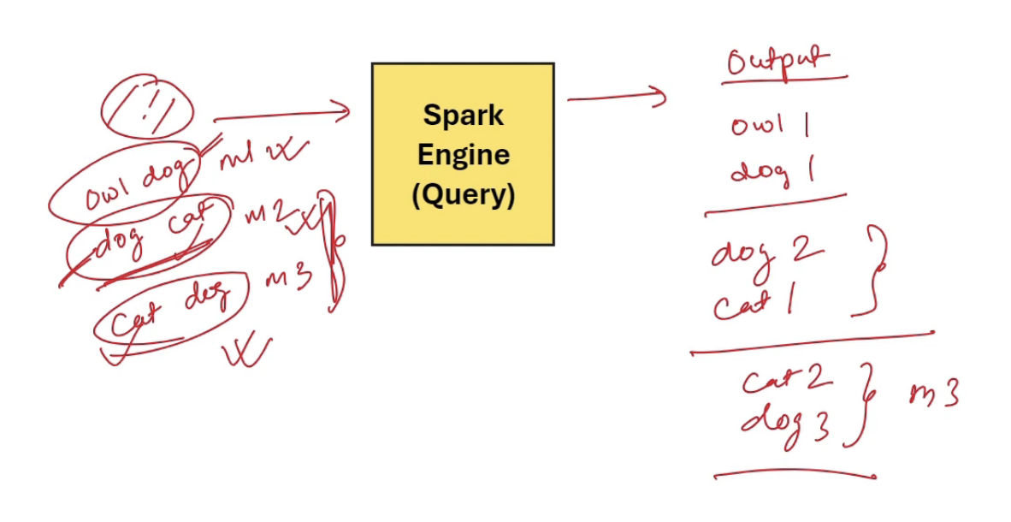

Append:

It will only show new data

State Store:

* 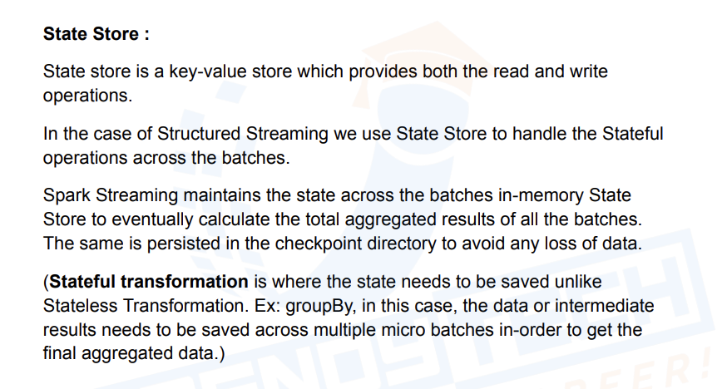

Lambda vs Kappa Architecture:

* 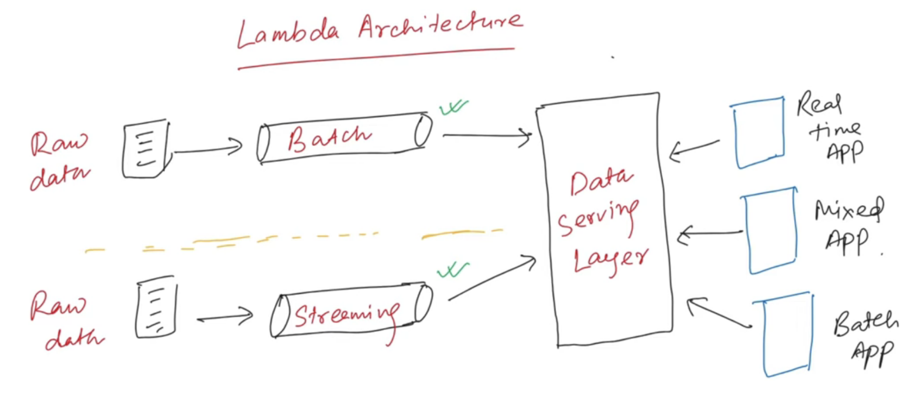
* 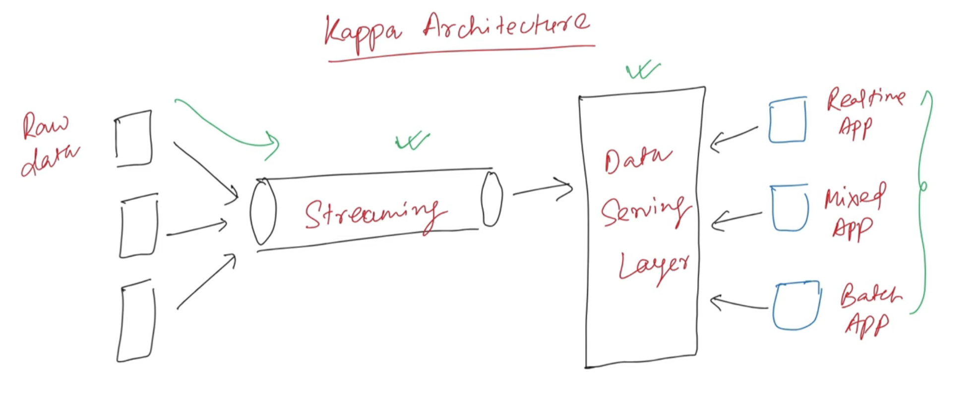
* 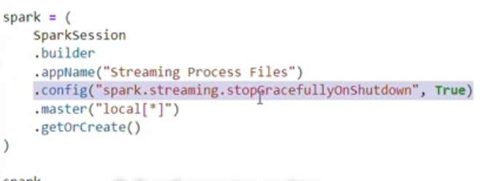
* When streaming application is shutdown, all data inline will be processed and shutdown gracefully
* For spark inferschema for streams, we use below config:
* 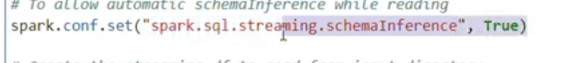

Batch Processing Code:

import findspark  
  
findspark.init()  
  
from pyspark.sql import SparkSession  
from pyspark.sql.functions import *  
spark = SparkSession.builder.appName("stream").getOrCreate()  
  
df = spark.read.format("json").load("./json_data/device_01.json")  
df_new = df.withColumn("data_new"**,**explode(col('data.devices')))  
df_final=df_new.withColumn("deviceId"**,**col('data_new.deviceId')) \  
 .withColumn("measure"**,**col('data_new.measure')) \  
 .withColumn("status"**,**col('data_new.status')) \  
 .withColumn("temperature"**,**col('data_new.temperature')).drop(col('data_new')).drop('data')  
df_final.show()

Stream Processing Code for same dataset:

import findspark  
  
findspark.init()  
  
from pyspark.sql import SparkSession  
from pyspark.sql.functions import *  
spark = SparkSession.builder.appName("stream") \  
 .config("spark.streaming.stopGracefullyOnShutdown"**,**True) \  
 .config("spark.sql.streaming.schemaInference"**,**True) \  
 .getOrCreate()  
  
df = spark.readStream.options(**{  
 "cleansource":"archive"**,** "sourceArchiveDir":"archive_dir"**,** "maxFilesPerTrigger":**1**}).format("json").load("./json_data")  
df_new = df.withColumn("data_new"**,**explode(col('data.devices')))  
df_final=df_new.withColumn("deviceId"**,**col('data_new.deviceId')) \  
 .withColumn("measure"**,**col('data_new.measure')) \  
 .withColumn("status"**,**col('data_new.status')) \  
 .withColumn("temperature"**,**col('data_new.temperature')).drop(col('data_new')).drop('data')  
df_final.writeStream.format("csv") \  
 .options(**{"path":"output_data/device/device_data.csv"**,** "checkpointLocation":"ckpt_dir"}) \  
 .outputMode("append").start().awaitTermination()

Checkpoint is a directory created by spark streaming to capture metadata

Checkpoint Dir:

* 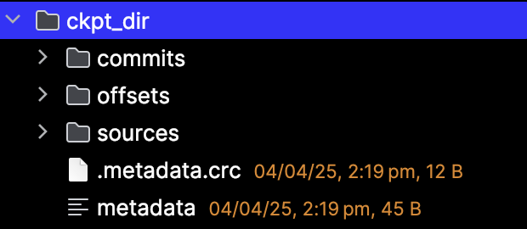
* Metadata file hold job id of streaming job
* 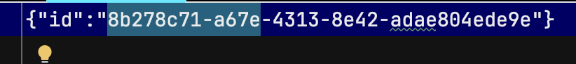
* 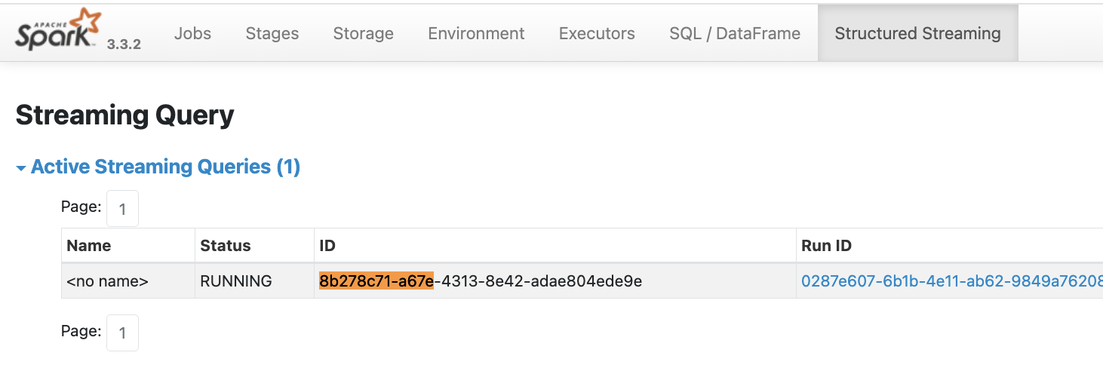
* Sources folder:  
  Keeps track of the source folder processed
* Offset:
* Keep track of files read and processed
* Once data is processed it will be updated in commit

If I remove file path from source file then same file will be reprocessed, otherwise even if u upload same file it will not process

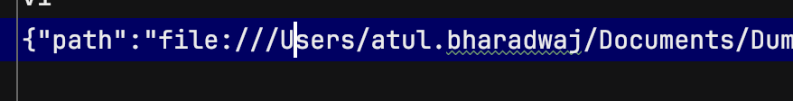

If u remove from commit then file will be written again

Read from kafka Topic:

from pyspark.sql import SparkSession  
  
spark = (  
 SparkSession   
 .builder   
 .appName("Streaming from Kafka")   
 .config("spark.streaming.stopGracefullyOnShutdown"**,** True)   
 .config('spark.jars.packages'**,** 'org.apache.spark:spark-sql-kafka-0-10_2.12:3.3.0')  
 .config("spark.sql.shuffle.partitions"**, 4**)  
 .master("local[*]")   
 .getOrCreate()  
)  
kafka_df = (  
 spark  
 .readStream  
 .format("kafka")  
 .option("kafka.bootstrap.servers"**,** "http://kafka-cp-kafka-headless.kafka.svc.cluster.local:9092")  
 .option("subscribe"**,** "device-data")  
 .option("startingOffsets"**,** "earliest")  
 .load()  
)  
from pyspark.sql.functions import *  
kafka_json_df = kafka_df.withColumn("value"**,**expr("cast(value as string)"))  
from pyspark.sql.types import StringType**,** StructField**,** StructType**,** ArrayType**,** LongType  
  
json_schema = (  
 StructType(  
 [StructField('customerId'**,** StringType()**,** True)**,** StructField('data'**,** StructType(  
 [StructField('devices'**,** ArrayType(StructType([   
 StructField('deviceId'**,** StringType()**,** True)**,** StructField('measure'**,** StringType()**,** True)**,** StructField('status'**,** StringType()**,** True)**,** StructField('temperature'**,** LongType()**,** True)  
 ])**,** True)**,** True)  
 ])**,** True)**,** StructField('eventId'**,** StringType()**,** True)**,** StructField('eventOffset'**,** LongType()**,** True)**,** StructField('eventPublisher'**,** StringType()**,** True)**,** StructField('eventTime'**,** StringType()**,** True)  
 ])  
)  
from pyspark.sql.functions import from_json**,**col  
  
streaming_df = kafka_json_df.withColumn("values_json"**,** from_json(col("value")**,** json_schema)).selectExpr("values_json.*")  
from pyspark.sql.functions import explode  
  
exploded_df = streaming_df.withColumn("data_devices"**,** explode("data.devices"))  
from pyspark.sql.functions import col  
  
flattened_df = (  
 exploded_df  
 .drop("data")  
 .withColumn("deviceId"**,** col("data_devices.deviceId"))  
 .withColumn("measure"**,** col("data_devices.measure"))  
 .withColumn("status"**,** col("data_devices.status"))  
 .withColumn("temperature"**,** col("data_devices.temperature"))  
 .drop("data_devices")  
)  
flattened_df \  
.writeStream \  
.format("console") \  
.outputMode("append") \  
.option("checkpointLocation"**,** "checkpoint_dir_kafka") \  
.start() \  
.awaitTermination()

Trigger Modes:

Once/Available Now: It is more like a batch processing, one time run

flattened_df \  
.writeStream \  
.format("console") \  
.trigger(once=True) \  
.outputMode("append") \  
.option("checkpointLocation"**,** "checkpoint_dir_kafka") \  
.start() \  
.awaitTermination()

Processing Time: It process for every fixed interval

# Running in once/availableNow and processingTime mode  
# Write the output to console sink to check the output  
  
(flattened_df  
 .writeStream  
 .format("console")  
 .outputMode("append")  
 .trigger(processingTime='10 seconds')  
 .option("checkpointLocation"**,** "checkpoint_dir_kafka_1")  
 .start()  
 .awaitTermination())

Continuous: It will be processing continuously but checkpoint will be updated every 10 seconds

# Running in Continuous mode  
# Write the output to memory sink to check the output  
  
(kafka_df  
 .writeStream  
 .format("memory")  
 .queryName("kafka_table")  
 .outputMode("append")  
 .trigger(continuous='10 seconds')  
 .option("checkpointLocation"**,** "checkpoint_dir_kafka_2")  
 .start()  
 .awaitTermination()  
 )

* Write Data to Multiple Sink
* 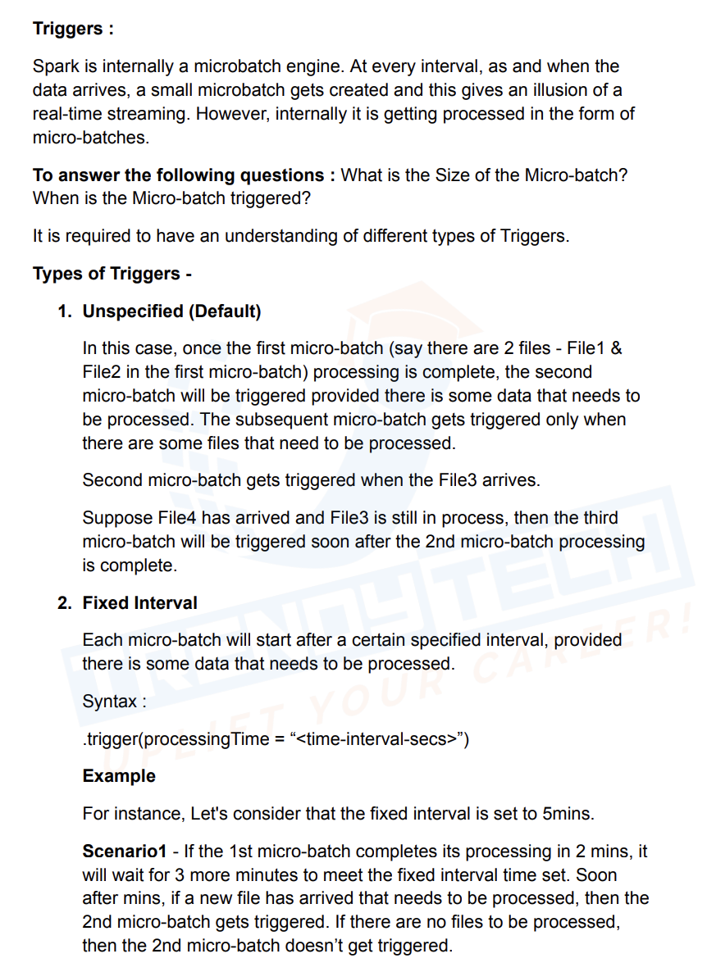
* 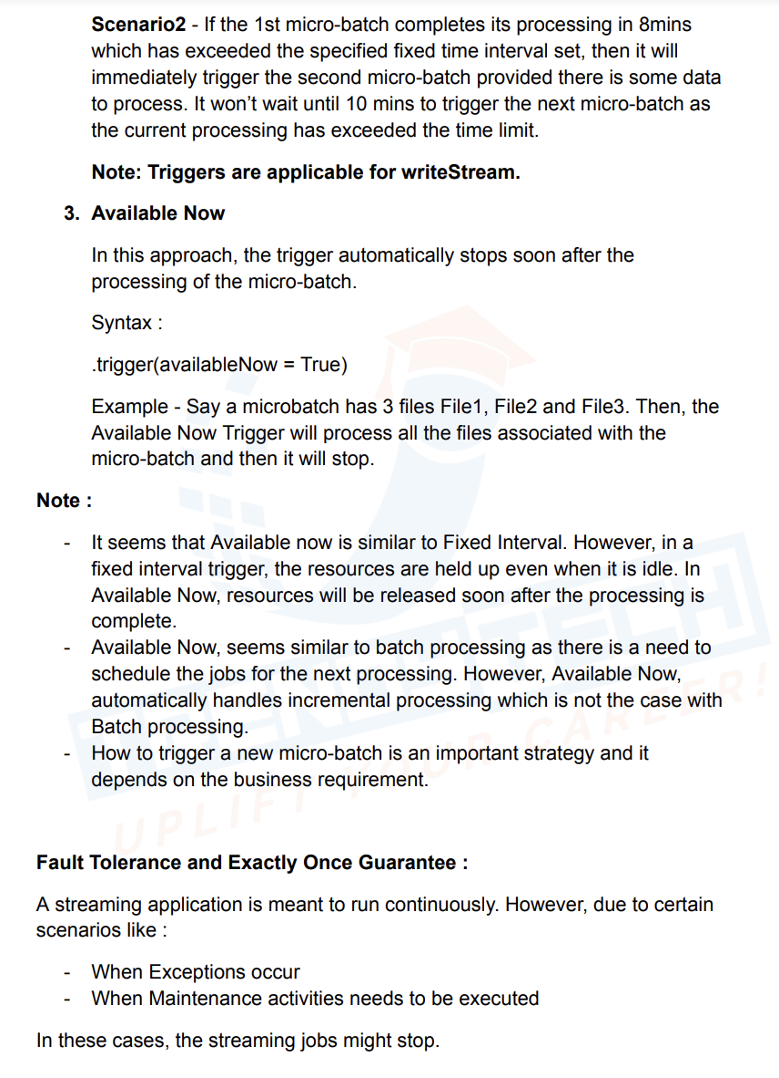
* 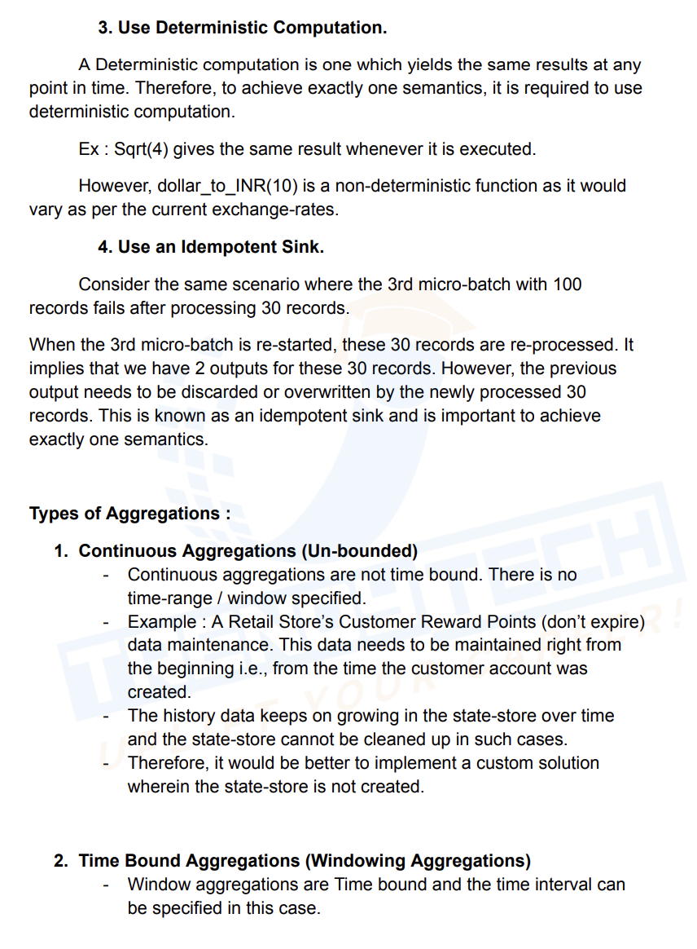
* 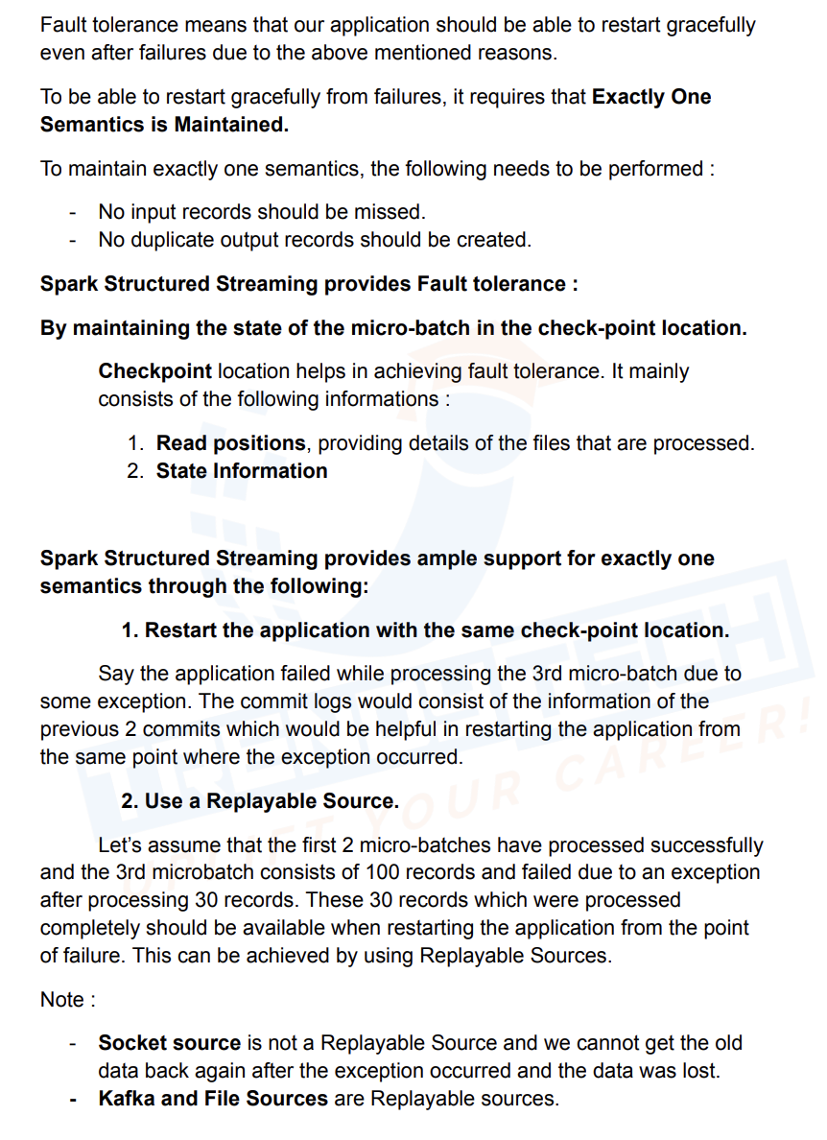
* 
* 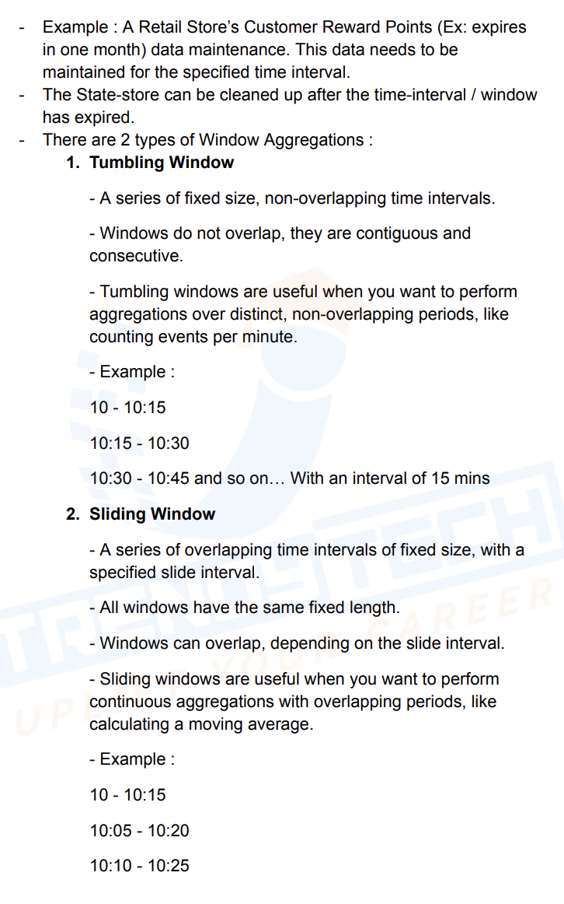
* 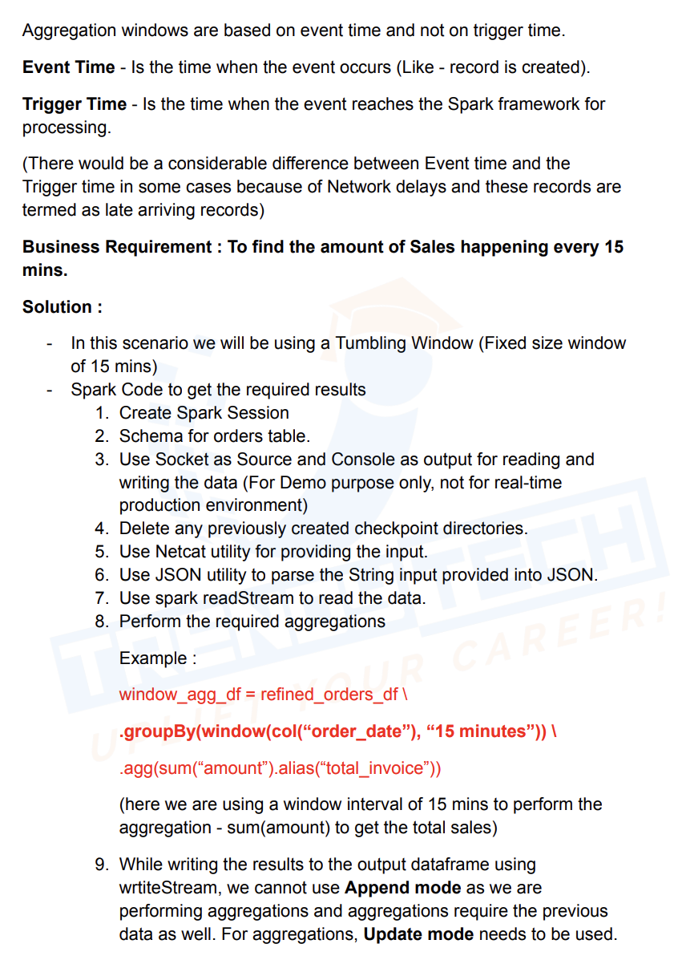
* 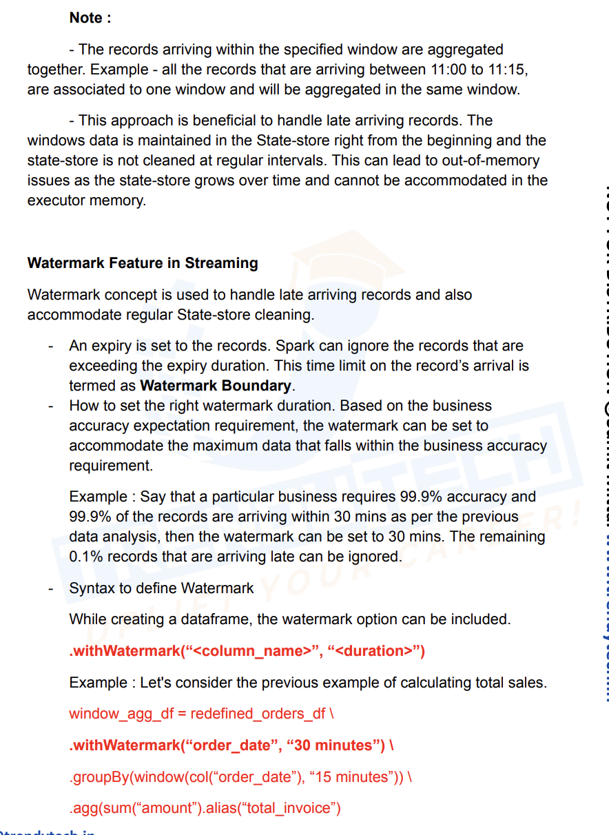
* 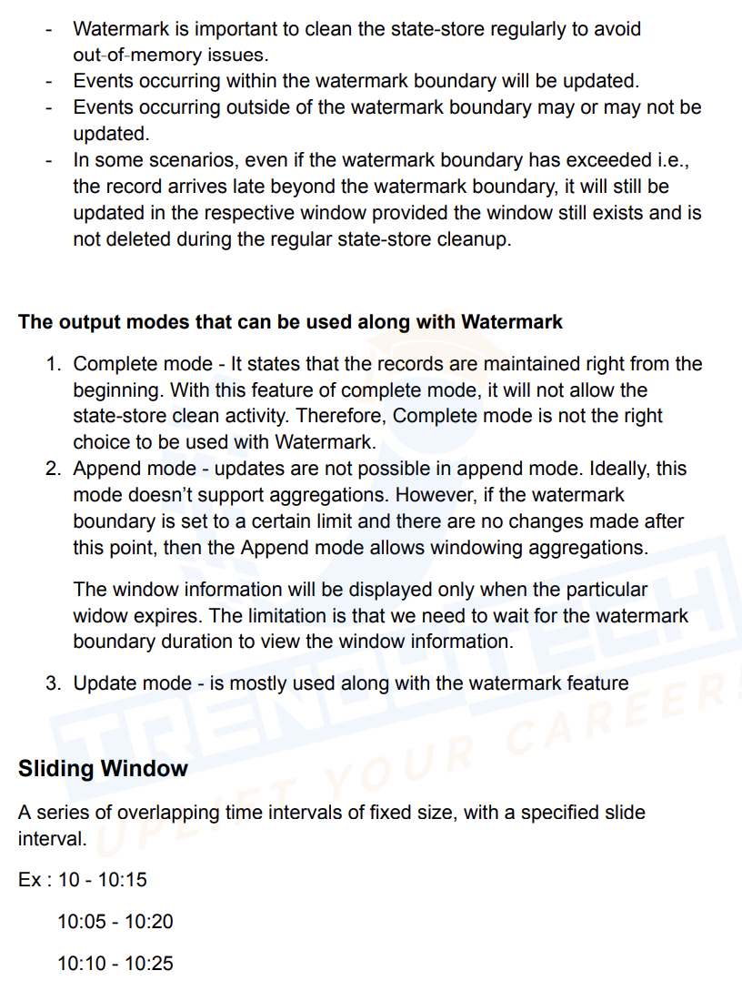
* 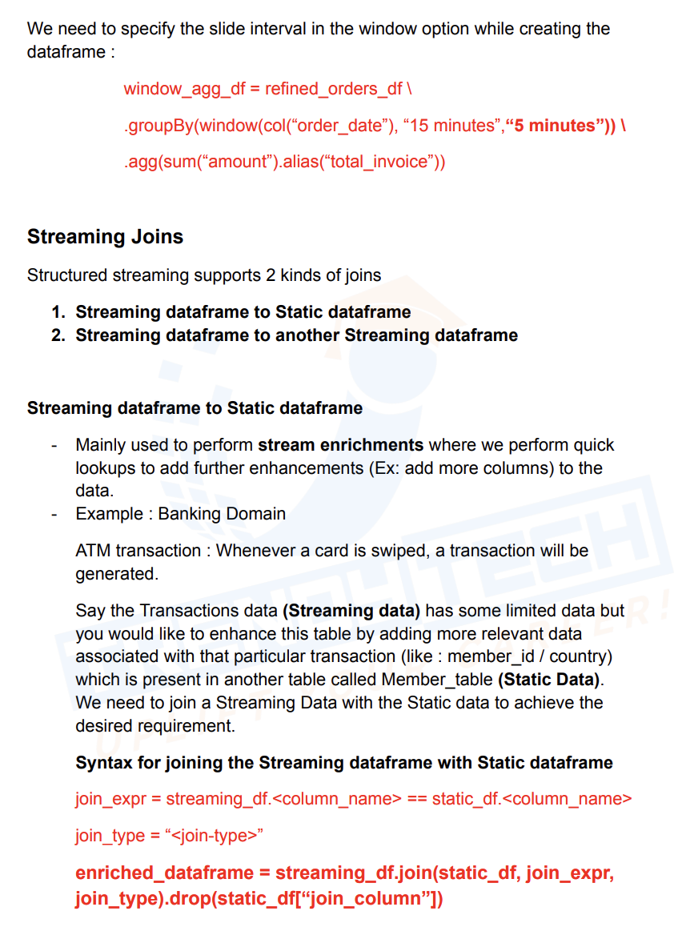
* 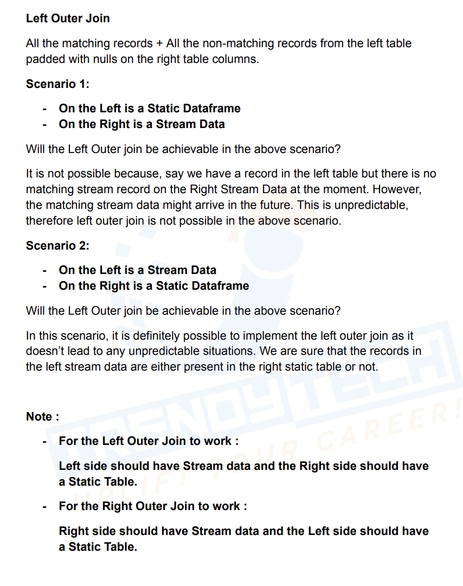

Problem with Multiple Sink:

* 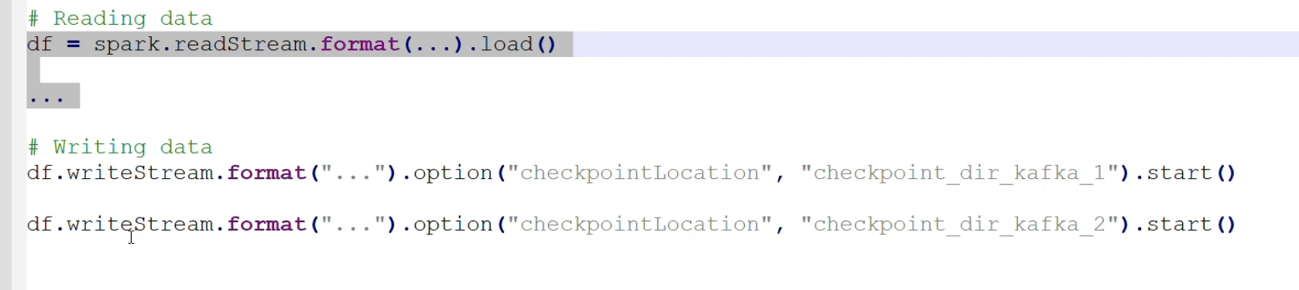
* Since we have 2 writes, as it’s an action, entire dag will be executed twice whenever write is called

And also one write can complete faster and other can be slower

We can resolve this using ForEach, it will executed for each micro batch, it will take df and batch_id as argument, so we have only one checkpoint for both the writes

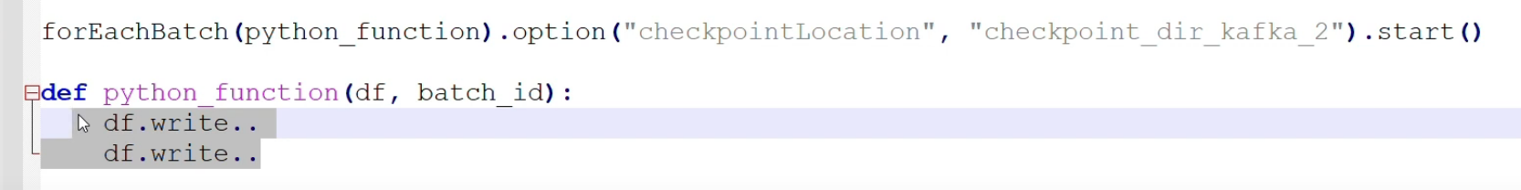

def device_data(df**,** batch_id)**:** print(f"batch_id: {batch_id}")  
 df.write.mode("append").save("./parquet_output")  
 df.write.format("jdbc").options(**{"driver"**:**"org.postgresql.Driver"**,** "url"**:**"jdbc:postgresql://postgres.postgres-dml.svc.cluster.local/postgres"**,** "dbtable"**:**"stream_test"**,** "user"**:**"postgres"**,** "password"**:**"wh0_kn0wz_wh4t_3v1l_1urks_th3_sh4d0w_kn0z"  
 }).save()  
 df.show()

flattened_df \  
.writeStream \  
.foreachBatch(device_data) \  
.trigger(processingTime='10 seconds') \  
.outputMode("append") \  
.option("checkpointLocation"**,** "checkpoint_dir_kafka") \  
.start() \  
.awaitTermination()

Handle Exception in Streaming:

from pyspark.sql import SparkSession  
  
spark = (  
 SparkSession  
 .builder  
 .appName("Streaming from Kafka")  
 .config("spark.streaming.stopGracefullyOnShutdown"**,** True)  
 .config('spark.jars.packages'**,** 'org.apache.spark:spark-sql-kafka-0-10_2.12:3.3.0,org.postgresql:postgresql:42.2.20')  
 .config("spark.sql.shuffle.partitions"**, 4**)  
 .master("local[*]")  
 .getOrCreate()  
)  
kafka_df = (  
 spark  
 .readStream  
 .format("kafka")  
 .option("kafka.bootstrap.servers"**,** "http://kafka-cp-kafka-headless.kafka.svc.cluster.local:9092")  
 .option("subscribe"**,** "device-data")  
 .option("startingOffsets"**,** "earliest")  
 .load()  
)  
from pyspark.sql import DataFrame  
from pyspark.sql.functions import from_json**,** col**,** expr**,** explode**,** current_timestamp**,** lit**,** size  
from pyspark.sql.types import StringType**,** StructField**,** StructType**,** ArrayType**,** LongType  
  
  
def flatten_data(df):  
 # Convert binary to string value column  
 kafka_json_df = df.withColumn("value"**,** expr("cast(value as string)"))  
  
 # Define Schema  
 json_schema = (  
 StructType(  
 [StructField('customerId'**,** StringType()**,** True)**,** StructField('data'**,** StructType(  
 [StructField('devices'**,** ArrayType(StructType([  
 StructField('deviceId'**,** StringType()**,** True)**,** StructField('measure'**,** StringType()**,** True)**,** StructField('status'**,** StringType()**,** True)**,** StructField('temperature'**,** LongType()**,** True)  
 ])**,** True)**,** True)  
 ])**,** True)**,** StructField('eventId'**,** StringType()**,** True)**,** StructField('eventOffset'**,** LongType()**,** True)**,** StructField('eventPublisher'**,** StringType()**,** True)**,** StructField('eventTime'**,** StringType()**,** True)  
 ])  
 )  
  
 # Expand JSON from Value column using Schema  
 json_df = kafka_json_df.withColumn("values_json"**,** from_json(col("value")**,** json_schema))  
  
 # Filter out for error data  
 error_df = json_df.select("key"**,** "value").withColumn("eventtimestamp"**,** lit(current_timestamp())) \  
 .where("values_json.customerId is null or size(values_json.data.devices) = 0")  
  
 # Filter out correct flattened data  
 streaming_df = json_df.where("values_json.customerId is not null and size(values_json.data.devices) > 0") \  
 .selectExpr("values_json.*")  
  
 # Explode the correct flattened data  
 exploded_df = streaming_df.withColumn("data_devices"**,** explode("data.devices"))  
  
 # Flatten data  
 flattened_df = (  
 exploded_df  
 .drop("data")  
 .withColumn("deviceId"**,** col("data_devices.deviceId"))  
 .withColumn("measure"**,** col("data_devices.measure"))  
 .withColumn("status"**,** col("data_devices.status"))  
 .withColumn("temperature"**,** col("data_devices.temperature"))  
 .drop("data_devices")  
 )  
  
 # Return both Flattened & Error Dataframe  
 return flattened_df**,** error_df  
def postgres(df**,** table_name):  
 (  
 df.write  
 .mode("append")  
 .format("jdbc")  
 .option("driver"**,** "org.postgresql.Driver")  
 .option("url"**,** "jdbc:postgresql://postgres.postgres-dml.svc.cluster.local:5432/postgres")  
 .option("dbtable"**,** table_name)  
 .option("user"**,** "postgres")  
 .option("password"**,** "wh0_kn0wz_wh4t_3v1l_1urks_th3_sh4d0w_kn0z")  
 .save()  
 )  
from pyspark.sql.functions import lit  
  
def device_data_output(kafka_df**,** batch_id):  
 print("Batch id:" + str(batch_id))  
 try:  
 # Get the Flattened and Error Dataframe  
 flattened_df**,** error_df_raw = flatten_data(kafka_df)  
  
 # Add the batchid column in Error Dataframe  
 error_df = error_df_raw.withColumn("batchid"**,** lit(batch_id))  
  
 # Write Flattened Dataframe to JDBC  
 postgres(flattened_df**,** "device_data")  
  
 # Write Error Datafram to JDBC  
 postgres(error_df**,** "device_data_error")  
  
 # Display both Dataframes for confirmation  
 flattened_df.show()  
 error_df.show()  
 except Exception as e:  
 print(f"Exception:{e}")  
 kafka_df.write.format("parquet").mode("append").save("data/output/device_data_error.parquet")  
kafka_df \  
.writeStream \  
.foreachBatch(device_data_output) \  
.trigger(processingTime='10 seconds') \  
.option("checkpointLocation"**,** "checkpoint_dir_kafka") \  
.start() \  
.awaitTermination()

Late Arrival Records:

* 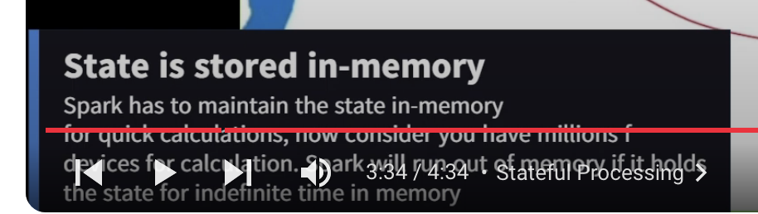

Tumbling Window/Fixed Window:

Size of the window remains same throughout the processing

* 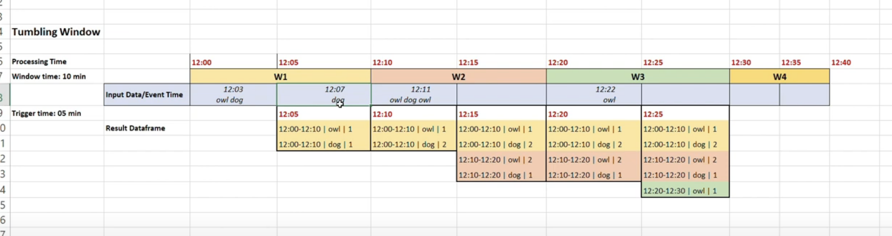

Sliding Window/Overlapping Window:

* 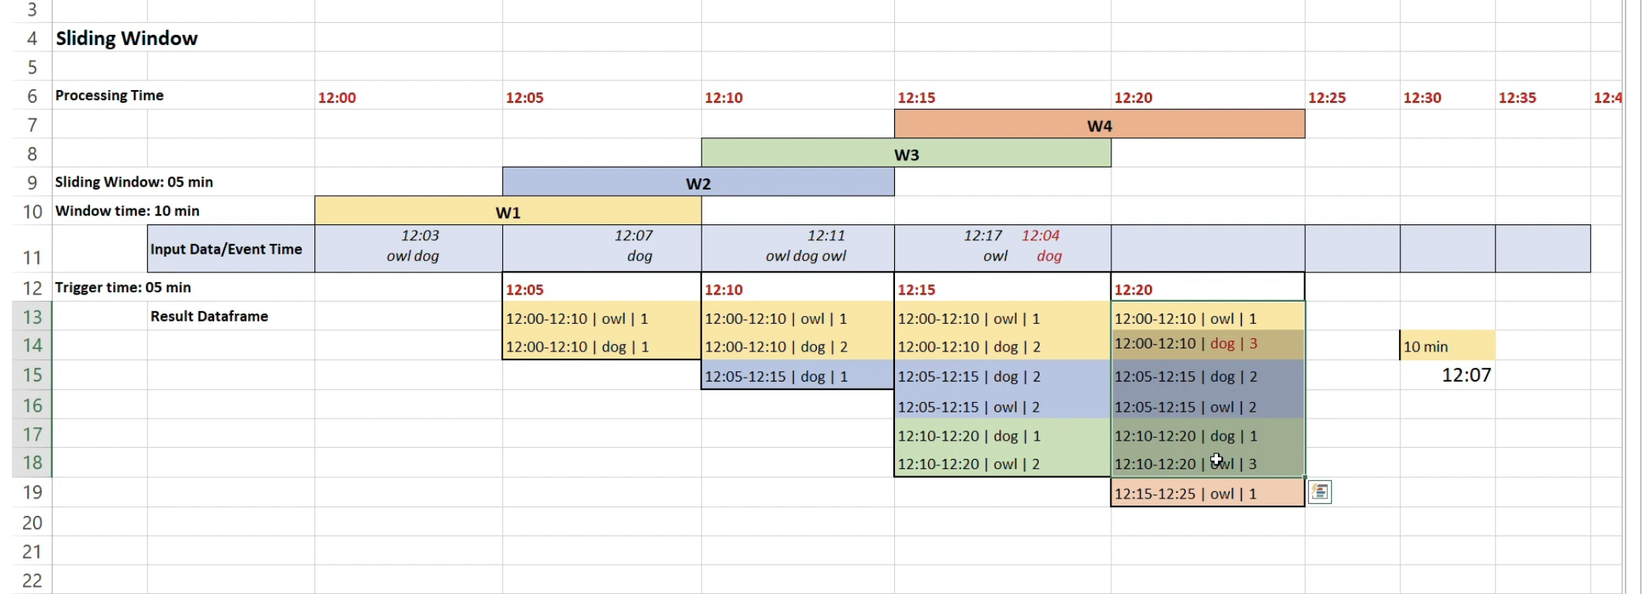

Watermark time is calculated based on latest event time

Session window:

* 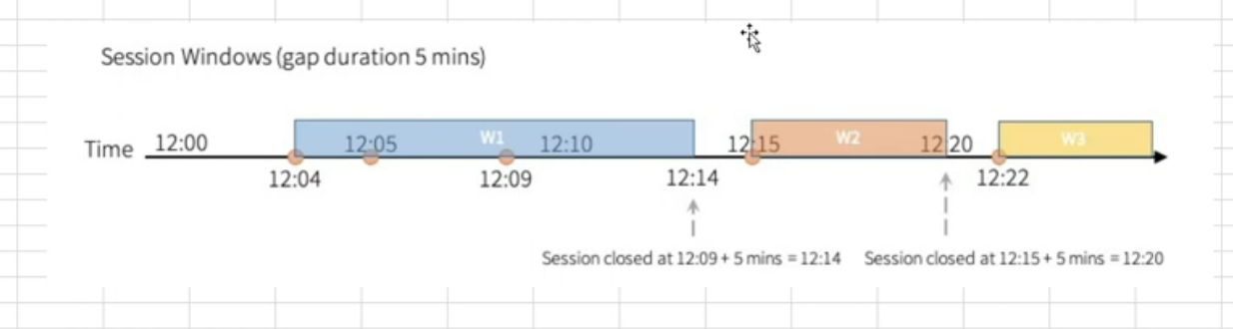

**Complete mode doesn’t work with watermark**

**{"event_time": "2024-04-09 12:20:00.000000", "data": "dog"}**

**This will come to 12:20 to 12:30 window not 12:10 to 12:20, range is not inclusive**

from pyspark.sql import SparkSession  
  
spark = (  
 SparkSession  
 .builder  
 .appName("Streaming from Kafka")  
 .config("spark.streaming.stopGracefullyOnShutdown"**,** True)  
 .config('spark.jars.packages'**,** 'org.apache.spark:spark-sql-kafka-0-10_2.12:3.3.0,org.postgresql:postgresql:42.2.20')  
 .config("spark.sql.shuffle.partitions"**, 4**)  
 .master("local[*]")  
 .getOrCreate()  
)  
  
kafka_df = (  
 spark  
 .readStream  
 .format("kafka")  
 .option("kafka.bootstrap.servers"**,** "http://kafka-cp-kafka-headless.kafka.svc.cluster.local:9092")  
 .option("subscribe"**,** "wildlife")  
 .option("startingOffsets"**,** "earliest")  
 .load()  
)  
  
# Convert binary to string value column  
from pyspark.sql.functions import expr  
  
kafka_json_df = kafka_df.withColumn("value"**,** expr("cast(value as string)"))  
  
from pyspark.sql.functions import from_json**,** col**,** split**,** explode  
  
# JSON Schema  
json_schema = "event_time string, data string"  
  
# Expand JSON from Value column using Schema  
json_df = kafka_json_df.withColumn("values_json"**,** from_json(col("value")**,** json_schema))  
flattened_df = json_df.select("values_json.event_time"**,**"values_json.data")  
words_df = flattened_df \  
 .withColumn("words"**,** split("data"**,** " ")) \  
 .withColumn("word"**,** explode("words")) \  
 .withColumn("event_time"**,** col("event_time").cast("timestamp"))  
  
from pyspark.sql.functions import count**,** lit**,** window  
  
df_agg = words_df \  
 .withWatermark("event_time"**,** "10 minutes") \  
 .groupBy(window("event_time"**,** "10 minutes")**,** "word").agg(count(lit(**1**)).alias("cnt"))  
  
df_final = df_agg.selectExpr("window.start as start_time"**,** "window.end as end_time"**,** "word"**,** "cnt")  
  
(df_final  
 .writeStream  
 .format("console")  
 .outputMode("update")  
 .trigger(processingTime='30 seconds')  
 .option("checkpointLocation"**,** "checkpoint_dir_kafka_3")  
 .start().awaitTermination()  
)